Lab 3 Report: Uninformed Search — BFS, DFS, DLS, IDDFS & UCS
Course: CS4944 / CA1601400 Artificial Intelligence Lab | Week 3 | CLO2 (C3: Apply)

Objective
The objective of this lab is to represent problems as state spaces and compare five uninformed search methods: Breadth-First Search (BFS), Depth-First Search (DFS), Depth-Limited Search (DLS), Iterative Deepening DFS (IDDFS), and Uniform Cost Search (UCS). The comparison focuses on completeness, optimality, path cost, and the order in which nodes are processed.

1. State-Space Formulation and Topology Assumptions
The emergency-exit problem starts at node A, and the goal test is node == G. When a node has more than one successor, the listed successor order is used to break ties. The root node A is at depth 0. Tasks 1 and 2 use the original unweighted A–G graph: A:[B,C], B:[D,E], C:[F], D:[], E:[G], F:[], G:[]. Task 3 uses the weighted extension described in Section 3.7. Its edge weights are nonnegative, and it includes the explicitly added C -> G corridor with weight 10. All visit and processing counts include the goal node G when it is popped and processed.
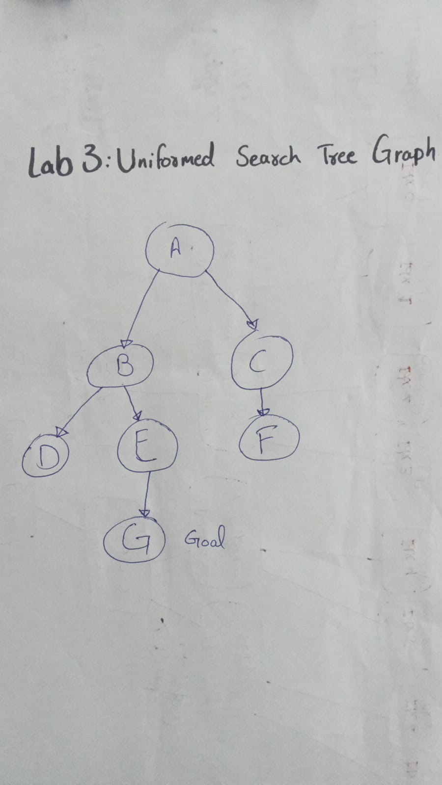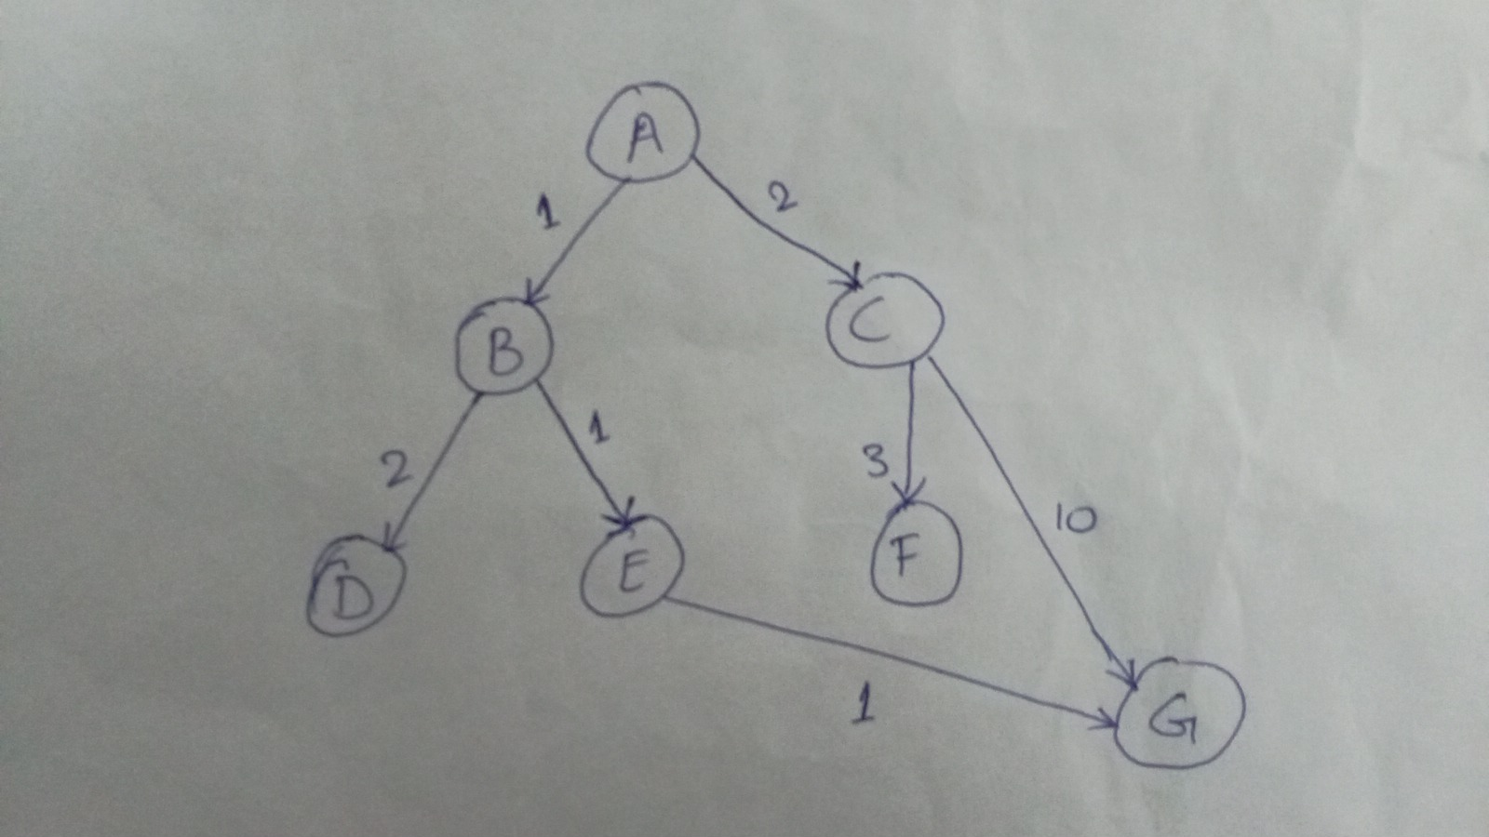

2. Task 1: Manual and Verified BFS & DFS Traces on the Original A–G Graph (lab3_bfs_dfs.py)
I worked through the BFS and DFS traces manually and then checked them against lab3_bfs_dfs.py using the original unweighted A–G graph. BFS uses a FIFO queue with popleft, so it processes nodes level by level in this order: ['A', 'B', 'C', 'D', 'E', 'F', 'G'] (7 nodes). DFS uses a LIFO stack and pushes reversed(graph[node]), meaning the first neighbor in the successor list is popped first. Its processing order is ['A', 'B', 'D', 'E', 'G'] (5 nodes). Both algorithms return the same unique path, ['A', 'B', 'E', 'G'], which contains 3 hops. This shows that the returned path alone does not reveal the order in which the graph was explored.
Algorithm & Step | Processed Node | Path to Processed Node | Frontier After Step (Queue Front→Back / Stack Bottom→Top) | Cumulative Visit Order
BFS Step 1 | A | ['A'] | Queue: ['B', 'C'] | ['A']
BFS Step 2 | B | ['A', 'B'] | Queue: ['C', 'D', 'E'] | ['A', 'B']
BFS Step 3 | C | ['A', 'C'] | Queue: ['D', 'E', 'F'] | ['A', 'B', 'C']
BFS Step 4 | D | ['A', 'B', 'D'] | Queue: ['E', 'F'] | ['A', 'B', 'C', 'D']
BFS Step 5 | E | ['A', 'B', 'E'] | Queue: ['F', 'G'] | ['A', 'B', 'C', 'D', 'E']
BFS Step 6 | F | ['A', 'C', 'F'] | Queue: ['G'] | ['A', 'B', 'C', 'D', 'E', 'F']
BFS Step 7 (Goal) | G | ['A', 'B', 'E', 'G'] | Queue: [] (stopped when goal processed) | ['A', 'B', 'C', 'D', 'E', 'F', 'G']
DFS Step 1 | A | ['A'] | Stack: ['C', 'B'] (reversed push) | ['A']
DFS Step 2 | B | ['A', 'B'] | Stack: ['C', 'E', 'D'] (reversed push) | ['A', 'B']
DFS Step 3 | D | ['A', 'B', 'D'] | Stack: ['C', 'E'] (D is a dead end) | ['A', 'B', 'D']
DFS Step 4 | E | ['A', 'B', 'E'] | Stack: ['C', 'G'] | ['A', 'B', 'D', 'E']
DFS Step 5 (Goal) | G | ['A', 'B', 'E', 'G'] | Stack: ['C'] (stopped when goal processed) | ['A', 'B', 'D', 'E', 'G']

3. Task 2: DLS and IDDFS at Depth Limits 1, 2, 3, and 4 (lab3_depth_search.py)
DLS and IDDFS were implemented with a path-local cycle check (nxt not in path) and three possible outcomes: FOUND, CUTOFF, and FAILURE. At limits 1 and 2, DLS returns CUTOFF rather than FAILURE. This happens because nodes at the depth limit still have children that have not been expanded: B and C at limit 1, and E at limit 2. The goal G is at depth 3. IDDFS starts again from the root at each new depth limit and does not carry a global visited set between runs. It therefore repeats some shallow expansions. By max_depth 3, it has processed 15 nodes in total. These repeated searches allow IDDFS to remain complete and find a shortest-hop solution.
Algorithm & Limit | Status | Returned Path | Limits Attempted | Nodes Processed (Including Goal When Reached)
DLS (limit = 1) | CUTOFF | None | [1] | ['A', 'B', 'C'] (3 nodes)
DLS (limit = 2) | CUTOFF | None | [2] | ['A', 'B', 'D', 'E', 'C', 'F'] (6 nodes)
DLS (limit = 3) | FOUND | ['A', 'B', 'E', 'G'] | [3] | ['A', 'B', 'D', 'E', 'G'] (5 nodes)
DLS (limit = 4) | FOUND | ['A', 'B', 'E', 'G'] | [4] | ['A', 'B', 'D', 'E', 'G'] (5 nodes)
IDDFS (max_depth = 1) | CUTOFF | None | [0, 1] | 4 total -> d=0:['A'], d=1:['A','B','C']
IDDFS (max_depth = 2) | CUTOFF | None | [0, 1, 2] | 10 total -> d=0..1 (4) + d=2:['A','B','D','E','C','F'] (6)
IDDFS (max_depth = 3) | FOUND | ['A', 'B', 'E', 'G'] | [0, 1, 2, 3] | 15 total -> d=0..2 (10) + d=3:['A','B','D','E','G'] (5)
IDDFS (max_depth = 4) | FOUND | ['A', 'B', 'E', 'G'] | [0, 1, 2, 3] | 15 total -> stops at depth 3 as soon as G is found

4. Task 3: Extended Weighted Graph and UCS vs. BFS Comparison (lab3_ucs.py)
For Task 3, the weighted graph uses these nonnegative travel costs: A->B(1), A->C(2), B->D(2), B->E(1), C->F(3), and E->G(1). It also includes the alternative C->G(10) corridor, explicitly added in Section 3.7. Unweighted BFS follows hop count and returns the two-hop route ['A', 'C', 'G']. Adding its edge weights gives a total cost of 2 + 10 = 12. UCS orders its priority queue by cumulative cost g(n). It therefore delays the expensive (12, 'G') entry from C and finds the three-hop route ['A', 'B', 'E', 'G'], with a total cost of 1 + 1 + 1 = 3.
Step / Metric | Processed / Algorithm | g(n) / Hops | Path / Cost (Reported & Summed) | Priority Queue / Processing Order Details
UCS Step 1 | A | g = 0 | ['A'] | PQ after step: [(1, 'B'), (2, 'C')]
UCS Step 2 | B | g = 1 | ['A', 'B'] | PQ after step: [(2, 'C'), (3, 'D'), (2, 'E')]
UCS Step 3 | C | g = 2 | ['A', 'C'] | PQ after step: [(2, 'E'), (3, 'D'), (5, 'F'), (12, 'G')]
UCS Step 4 | E | g = 2 | ['A', 'B', 'E'] | PQ after step: [(3, 'D'), (3, 'G'), (5, 'F'), (12, 'G')]
UCS Step 5 | D | g = 3 | ['A', 'B', 'D'] | PQ after step: [(3, 'G'), (12, 'G'), (5, 'F')]
UCS Step 6 (Goal) | G | g = 3 | ['A', 'B', 'E', 'G'] | Goal popped at cost 3; remaining PQ: [(5, 'F'), (12, 'G')]
Comparison: BFS | Unweighted BFS | 2 hops | Path: ['A', 'C', 'G'] | Cost Sum = 12 | Order (7): ['A', 'B', 'C', 'D', 'E', 'F', 'G'] (minimizes hops, ignores weights)
Comparison: UCS | Weighted UCS | 3 hops | Path: ['A', 'B', 'E', 'G'] | Cost = 3 (Sum = 3) | Order (6): ['A', 'B', 'C', 'E', 'D', 'G'] (minimizes total travel cost)

5. Edge-Case Analysis and Limitations
Edge Case Test | Input & Graph | Observed Behavior | Interpretation / Limitation & Proposed Improvement
1. Start Equals Goal | start='A', goal='A' (all algorithms) | Returns path=['A'], cost=0 (UCS), processed=['A']. | Checking the goal as soon as it is popped handles a zero-step route correctly.
2. Unreachable Goal (CUTOFF vs FAILURE) | start='A', goal='Z' on the original A–G graph | DLS(limit=2) -> CUTOFF; DLS(limit=4) -> FAILURE; BFS/DFS/UCS -> None after exhausting all 7 nodes. | This shows that limit=2 only means the depth bound stopped the search. At limit=4, the search establishes that Z cannot be reached.
3. Cyclic Graph Handling | Cyclic unweighted (A<->B->D->G) and weighted (A<->B->C->G) | BFS/DFS/IDDFS find an optimal 3-hop path; UCS finds the cost-5 path ['A','B','C','G'] without entering an infinite loop. | Limitation: UCS requires nonnegative edge weights. If negative edges are present, Bellman-Ford should be used.

6. Reflection, Responsible Practice, and Conclusion

Reflection
I learned that the data structure used for the frontier—a FIFO queue, LIFO stack, or min-heap—determines the order in which nodes are explored. I also saw why the number of hops in a path can differ from its total cost. For a real AI navigation system, I would choose UCS or A* when travel costs vary, and IDDFS when each step has the same cost and memory is limited. One useful observation was that the C->G route entered the priority queue early with a cost of 12, but UCS chose the E->G route instead because its total cost was only 3. In a future test, I would measure memory use on graphs with larger branching factors.

Responsible Practice & Conclusion
The search traces were taken directly from the original program executions. The visit orders were not changed, so the recorded results remain traceable to the experiments.

7. References
1. Russell, S., & Norvig, P. (2020). Artificial Intelligence: A Modern Approach (4th ed., Chapter 3: Solving Problems by Searching). Pearson.
2. CS4944 / CA1601400 Artificial Intelligence Lab Manual, Lab 3: Uninformed Search (Sections 3.1–3.8).

